**CSF 2113 Lab 5.2: Containers (Tuple & Dictionaries)**

1. **Using Tuples in Python**

**Tuples are a collection of data items. They may be of different types. Tuples are immutable (like strings). Python optionally uses brackets () to denote tuples**

**We could have also used () for the above tuple**

**If we have only one item, we need to use a comma to indicate it's a tuple: e.g. (“Bat”,)**

1. **Creation:** Create a touple of following information about a student. Name the tuple std.

“Fatima”, 3.4, 78,”Sharjah”



|  |
| --- |
|  |

1. Create a tuple where one element is a list and rest are numbers:



|  |
| --- |
|  |

1. **Indexing**: Tuple elements can be accessed by index: try out following element in above created lists:

tup[0]

tup[-1]

tup[3]

tup[-4]

|  |
| --- |
|  |

1. **Slicing:** All slice operations return a new tuple containing the requested elements. This means that the following slice returns a new (shallow) copy of the tuple. Perform following slicing operations on above created tuple:

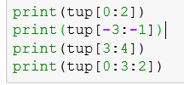

|  |
| --- |
|  |

1. **Mutable**: Tuples are immutable. We cannot change the value of an index. Try out following.

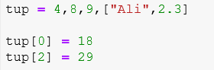

|  |
| --- |
|  |

1. **Sorting a Tuple**: As tuple are immutable sorting a tuple is not possible however we can sort by using sorted function which not change the tuple will rather return a sorted list of elements of tuple.

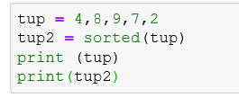

|  |
| --- |
|  |

1. **Sorting a Tuple**: We can use this sorted list to create another tuple.

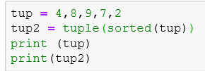

|  |
| --- |
|  |

1. **Other functions of tuple**: We can use variety of functions with tuple.

|  |  |  |  |
| --- | --- | --- | --- |
| **Function** | **purpose** | **code** | **output** |
| length | Total length of tuple |  |  |
| concatenation | Concatenate two or more tuples |  |  |
| Repetition | Repeat the sequence of element |  |  |
| Membership | Check the element is present in tuple |  |  |
| Max | Find maximum value in tuple |  |  |
| Min | Find minimum value in tuple |  |  |

1. **Using Dictionaries in Python**

**A dictionary is like a list, but more general. In a list, the indices have to be integers; in a dictionary they can be (almost) any type. Keys must be *unique* within a dictionary: No *duplicates.* Simply put, a dictionary is a list of key-value pairs.**

1. Create two dictionary variables: One an empty dictionary and one with student’s marks as shown in the image below. Than Display the contents of dictionaries.

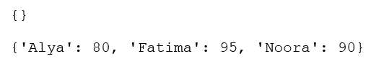

|  |
| --- |
|  |

1. Write down the output of the following python code segment.

|  |
| --- |
|  |
|  |

1. Create a dictionary with three items as per given screenshot.



Display following:

* List of all items in the dictionary “student_marks”
* List of all keys in the dictionary “student_marks”
* List of all the values in the dictionary “student_marks”

|  |
| --- |
|  |

1. Write down the output of the following code segment.

|  |
| --- |
|  |
|  |

1. Write down the output of the following code segment.

|  |
| --- |
|  |
|  |

1. Write down the output of the following code segment.

|  |
| --- |
|  |
|  |

1. Write down the output of the following code segment.

|  |
| --- |
|  |
|  |

**End of Lab**